GREAT PUMPKIN SEED GUESS RESULTS

T
hank you to everyone who came by to guess how many seeds were in the Great Pumpkin at the Science committee table at the Fall Festival! That big ol’ pumpkin sure seemed to have a lot of seeds! But, in fact, the number of seeds inside was . . . .only 87! The winners were announced Friday at school and called that evening. Congratulations to Juliana P. for K-3, Geoffrey P. for 4-6 and Eric D. and Jason P. (a tie) for the parent/teacher category. Thanks to everyone who came by to make a guess and support the Science Committee. We raised $81 for upcoming events!
Thank You
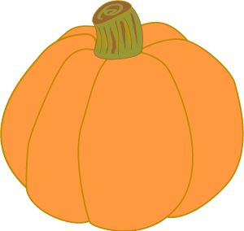

YOGA FOR KIDS

Ms. Medina, 1st grade teacher at Mattos, will begin her “yoga for kids” classes on Thursday, November 17. The class will be held in her classroom, Room 4, from 3:15 until 4:00 p.m. Class dates are November 17, December 1, 8, 15, and 21. Session fee for all 5 classes is $45. Please contact Ms. Medina at 793-1359, ext. 65004.

Many thanks to parent volunteer Traci Denny for helping to make Picture Make-up Day run so smoothly!

